WEEK 2-PL/SQL PROGRAMMING

EXERCISE 1: CONTROL STRUCTURES

Scenario 1: The bank wants to apply a discount to loan interest rates for customers above 60 years old.
  - Question: Write a PL/SQL block that loops through all customers, checks their age, and if they are above 60, apply a 1% discount to their current loan interest rates.

CREATE TABLE bank_customers (
customer_id NUMBER PRIMARY KEY,
name VARCHAR2(50),
age NUMBER,
balance NUMBER,
interest_rate NUMBER(5,2),
isVIP VARCHAR2(5)
);
INSERT INTO bank_customers VALUES (1, 'Alice', 65, 12000, 7.5, 'FALSE');
INSERT INTO bank_customers VALUES (2, 'Bob', 45, 8000, 6.0, 'FALSE');
INSERT INTO bank_customers VALUES (3, 'Charlie', 70, 15000, 8.0, 'FALSE');
INSERT INTO bank_customers VALUES (4, 'David', 30, 5000, 5.5, 'FALSE');
select * from bank_customers;

INTIAL TABLE:
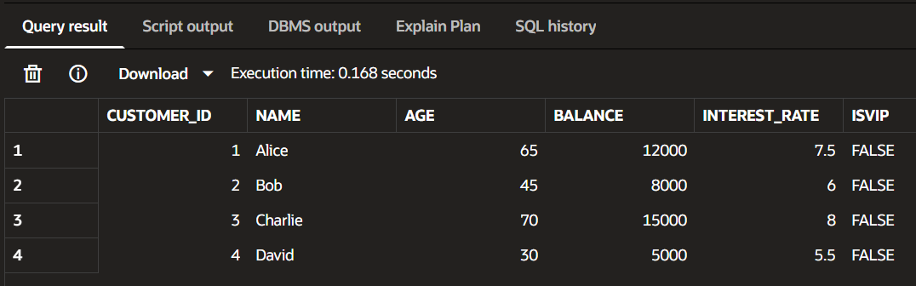
BEGIN
-- Loop through each customer
FOR c IN (
SELECT customer_id, age
FROM bank_customers
)
LOOP
-- Check if customer is above 60
IF c.age > 60 THEN
-- Reduce interest rate by 1%
UPDATE bank_customers
SET interest_rate = interest_rate - 1
WHERE customer_id = c.customer_id;
END IF;
END LOOP;
-- Save the changes
COMMIT;
END;
/
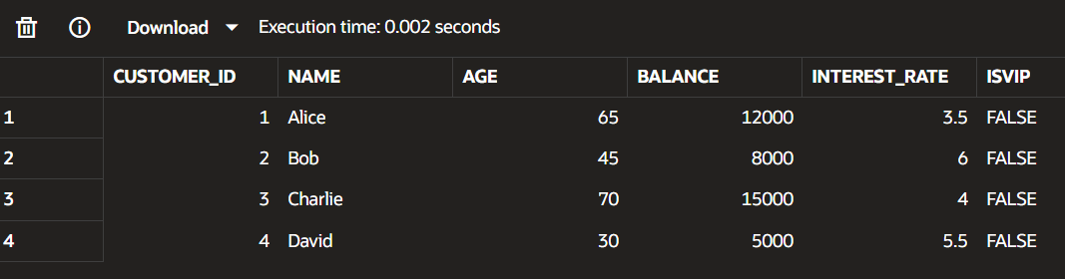

Scenario 2: A customer can be promoted to VIP status based on their balance.
  - Question: Write a PL/SQL block that iterates through all customers and sets a flag IsVIP to TRUE for those with a balance over $10,000.

SET SERVEROUTPUT ON;
BEGIN
FOR c IN (
SELECT customer_id, balance
FROM bank_customers
)
LOOP
IF c.balance > 10000 THEN
UPDATE bank_customers
SET isVIP = 'TRUE'
WHERE customer_id = c.customer_id;

DBMS_OUTPUT.PUT_LINE(
'VIP status updated for Customer ID: ' || c.customer_id
);
END IF;

END LOOP;

COMMIT;

END;
/
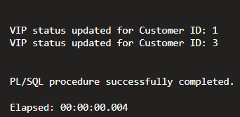
Scenario 3: Send Reminders for Loans Due Within 30 Days
CREATE TABLE bank_loans (
loan_id NUMBER PRIMARY KEY,
customer_id NUMBER,
due_date DATE
);

Insert Sample Data
INSERT INTO bank_loans VALUES (101, 1, SYSDATE + 10);
INSERT INTO bank_loans VALUES (102, 2, SYSDATE + 40);
INSERT INTO bank_loans VALUES (103, 3, SYSDATE + 20);
INSERT INTO bank_loans VALUES (104, 4, SYSDATE + 5);
COMMIT;
PL/SQL CODE:
SET SERVEROUTPUT ON;

BEGIN
-- Loop through loans due within the next 30 days
FOR c IN (
SELECT bc.customer_id,
bc.name,
bl.due_date
FROM bank_customers bc
JOIN bank_loans bl
ON bc.customer_id = bl.customer_id
WHERE bl.due_date BETWEEN SYSDATE AND SYSDATE + 30
)
LOOP
-- Print reminder
DBMS_OUTPUT.PUT_LINE(
'Reminder sent to '
|| c.name
|| ' (Customer ID: '
|| c.customer_id
|| ')'
);
END LOOP;
END;
/
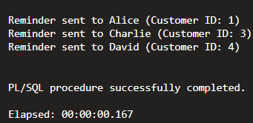
FINAL OUTPUT TABLE:
SELECT bc.customer_id,
bc.name,
bl.loan_id,
bl.due_date
FROM bank_customers bc
JOIN bank_loans bl
ON bc.customer_id = bl.customer_id;

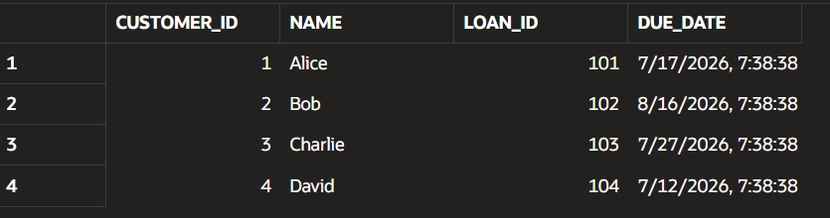

Exercise 3: Stored Procedures
Scenario 1: The bank needs to process monthly interest for all savings accounts.
  - Question: Write a stored procedure ProcessMonthlyInterest that calculates and updates the balance of all savings accounts by applying an interest rate of 1% to the current balance.
Create Table
CREATE TABLE savings_accounts(
account_id NUMBER PRIMARY KEY,
customer_name VARCHAR2(50),
balance NUMBER(10,2)
);
INSERT INTO savings_accounts VALUES (101, 'Alice', 10000);
INSERT INTO savings_accounts VALUES (102, 'Bob', 5000);
INSERT INTO savings_accounts VALUES (103, 'Charlie', 20000);
INSERT INTO savings_accounts VALUES (104, 'David', 15000);
COMMIT;
CREATE OR REPLACE PROCEDURE ProcessMonthlyInterest
IS
BEGIN
-- Increase every balance by 1%
UPDATE savings_accounts
SET balance = balance + (balance * 0.01);
COMMIT;
END;
/
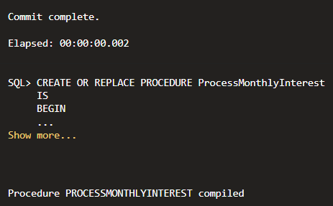

Scenario 2: The bank wants to implement a bonus scheme for employees based on their performance.
  - Question: Write a stored procedure UpdateEmployeeBonus that updates the salary of employees in a given department by adding a bonus percentage passed as a parameter.
CREATE TABLE:
CREATE TABLE employees (
emp_id NUMBER PRIMARY KEY,
emp_name VARCHAR2(50),
department VARCHAR2(30),
salary NUMBER(10,2)
);
INSERT INTO employees VALUES (101,'Alice','IT',50000);
INSERT INTO employees VALUES (102,'Bob','HR',40000);
INSERT INTO employees VALUES (103,'Charlie','IT',60000);
INSERT INTO employees VALUES (104,'David','Finance',45000);
COMMIT;

CREATE OR REPLACE PROCEDURE UpdateEmployeeBonus(
p_department IN VARCHAR2,
p_bonus IN NUMBER
)
IS
BEGIN
-- Increase salary of employees in the given department
UPDATE employees
SET salary = salary + (salary * p_bonus / 100)
WHERE department = p_department;

COMMIT;
END;
/
BEGIN
UpdateEmployeeBonus('IT',10);
END;
SELECT * FROM employees;


Scenario 3: Customers should be able to transfer funds between their accounts.
- Question: Write a stored procedure TransferFunds that transfers a specified amount from one account to another, checking that the source account has sufficient balance before making the transfer.

CREATE TABLE accounts (
account_id NUMBER PRIMARY KEY,
customer_name VARCHAR2(50),
balance NUMBER(10,2)
);
INSERT INTO accounts VALUES (101, 'Alice', 10000);
INSERT INTO accounts VALUES (102, 'Bob', 5000);
INSERT INTO accounts VALUES (103, 'Charlie', 8000);
COMMIT;
CREATE OR REPLACE PROCEDURE TransferFunds(
p_from_account IN NUMBER,
p_to_account IN NUMBER,
p_amount IN NUMBER
)
IS
v_balance NUMBER;
BEGIN
-- Get source account balance
SELECT balance
INTO v_balance
FROM accounts
WHERE account_id = p_from_account;

-- Check sufficient balance
IF v_balance >= p_amount THEN
-- Deduct amount from source account
UPDATE accounts
SET balance = balance - p_amount
WHERE account_id = p_from_account;
-- Add amount to destination account
UPDATE accounts
SET balance = balance + p_amount
WHERE account_id = p_to_account;

COMMIT;
DBMS_OUTPUT.PUT_LINE('Fund Transfer Successful');
ELSE
DBMS_OUTPUT.PUT_LINE('Insufficient Balance');
END IF;
END;
/
BEGIN
TransferFunds(101,102,2000);
END;

FINAL OUTPUT TABLE:
SELECT * FROM accounts;
